**Name**:Esraa Nagm Mohamed Yehia

**B.N/**176

**Date**: 6-6-2021

**Topic**: Operating Systems

**Application Brief**: I am interested in this topic because it is the latest breakthrough in the fields of computers.

**GitHub-Link:**

**GitHub-Page(Published Website):**

**Screenshots**:

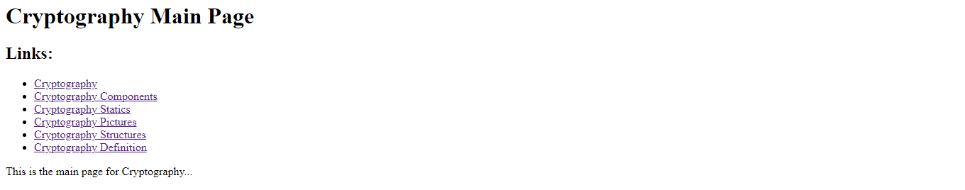

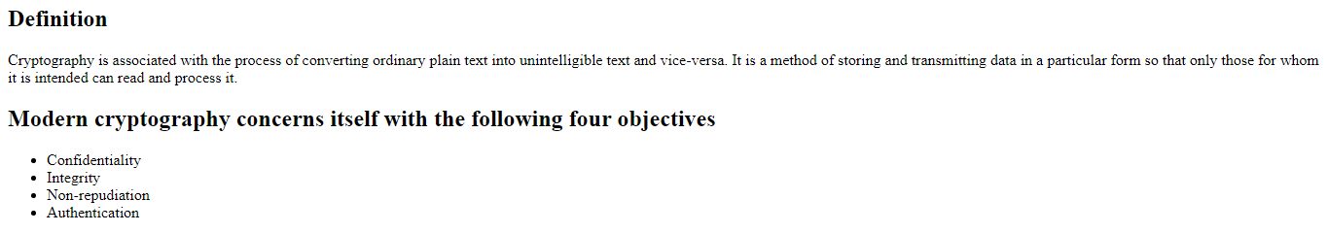

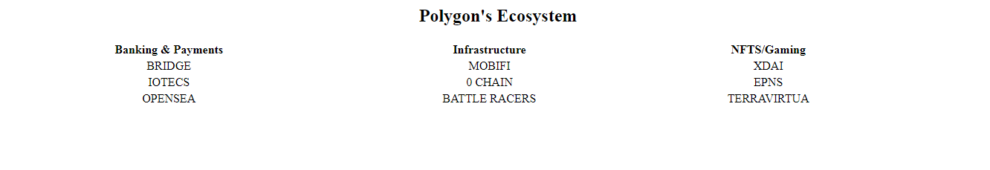

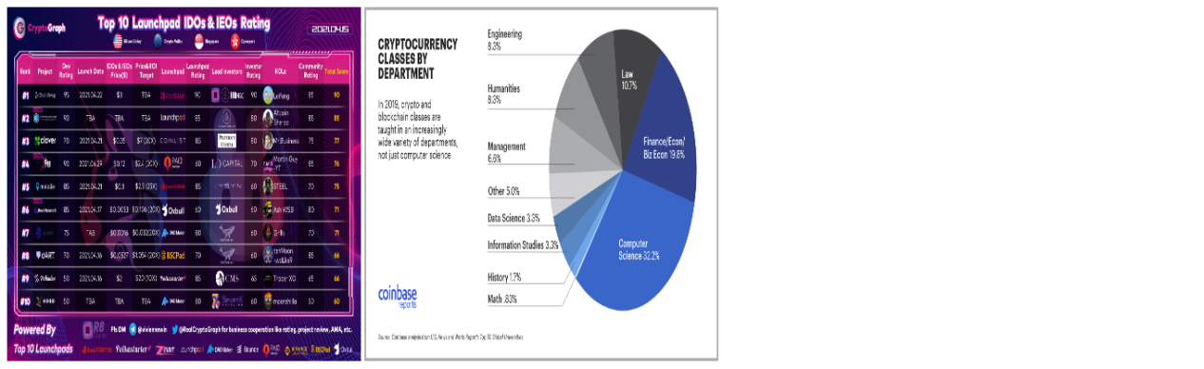

**Source Code**:

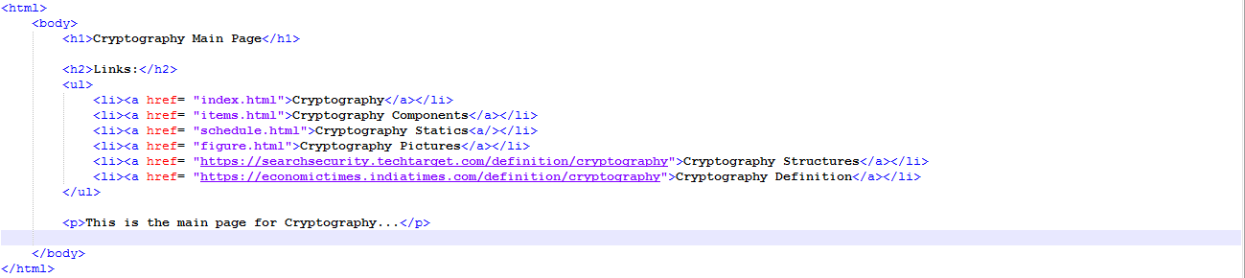

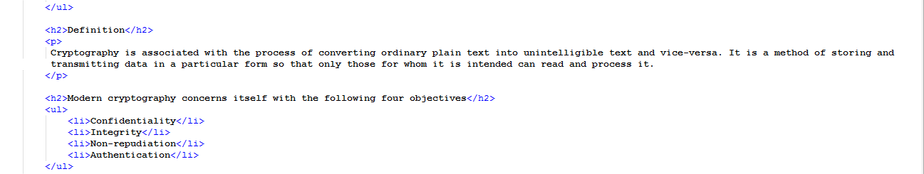

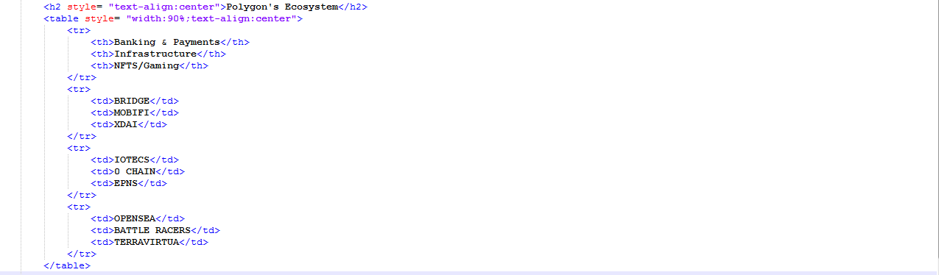

8